CAS SciFinder Task History

January 3, 2025, 2:47 PM

Initiating Search

Reactions: | Structure Search  

Filtered By:
Structure Match: As Drawn
Substance Role: Reactant
Yield: 90-100%
Non-Participating Functional Groups: Ether, Alkene, Organometal, Cyclic alkene, Amine, Diene, Cyclopentadienyl metal, Tertiary amine, Carboxamidine, Amide, Imine, Alcohol, Ketone, Primary amine, Urea, Acetal, Acyclic alkene, Acyclic ketone, Carboxylic ester, Halide, Primary alcohol, Secondary amine, Nitrile, Carboxylic acid, Phenyl halide, Sulfide, Aldehyde, Alkyl halide, Alkyne, Cyclic alcohol, Cyclic ketone, Nitro, Secondary alcohol, Unsaturated ester, Phosphonate
Reaction Type: Full
Language: English
Publication Year: 2000 to 2024

Excluded:
Reaction Mapping: No Mapping Data Available
Solvent: THF-d₈, Acetonitrile-d₃, Benzene-d₆
Reaction Notes: Thermal, Microwave Irradiation, Ultrasound
CA Section: Electrochemical, Radiational, and Thermal Energy Technology, Magnetic Phenomena

Search Tasks

1. Exported: Returned Reaction Results + Filters (152) View Results

View in CAS SciFinder

Reactions (50)

1. Scheme 1 (1 Reaction)

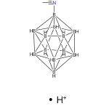  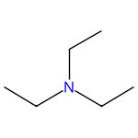 |  | 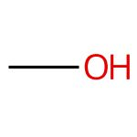 |  | 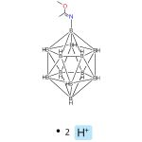

Nucleophilic addition reactions to nitrilium derivatives [B12H11NCCH3]- and [B12H11NCCH2CH3]-. Synthesis and structures of closo-dodecaborate-based iminols, amides and amidines
By: Laskova, Julia; et al
Dalton Transactions (2022), 51(8), 3051-3059.
Find It @ Emory
10.1039/d1dt04174f
View All Sources in CAS SciFinder

Steps: 1, Yield: 100%
CAS Reaction Number: 31-614-CAS-34355987
1.1 | Solvents: Acetonitrile; 12 h, rt

2. Scheme 2 (1 Reaction)

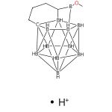  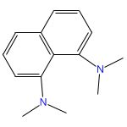 |  |  |  | 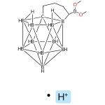

Selective cage boron/carbon extrusion reaction of 13-vertex carborane μ-1,2-(CH2)3-1,2-C2B11H11: Formation of nido-CB10, closo-CB10, and closo-C2B10 species
By: Zhang, Jian; et al
Chemical Communications (Cambridge, United Kingdom) (2011), 47(28), 8082-8084.
Find It @ Emory
10.1039/c1cc12023a
View All Sources in CAS SciFinder

Steps: 1, Yield: 99%
CAS Reaction Number: 31-614-CAS-28437728
1.1 | Reagents: Triethylamine
 | Solvents: Methanol; 24 h, rt

3. Scheme 3 (3 Reactions)

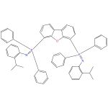  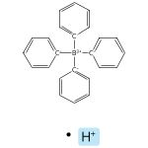 |  | 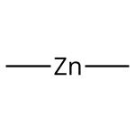 |  | 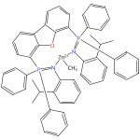  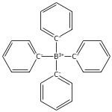

Exploring the versatility of a bis(phosphinimine) pincer ligand: effect of sterics on structure and lactide polymerization activity of cationic zinc complexes
By: Wheaton, Craig A.; et al
Catalysis Science & Technology (2012), 2(1), 125-138.
Find It @ Emory
10.1039/c1cy00306b
View All Sources in CAS SciFinder

Steps: 1, Yield: 100%
CAS Reaction Number: 31-562-CAS-4397521
1.1 | Solvents: Bromobenzene, Toluene; 30 min, rt

Catalysts for the polymerization of cyclic lactones
Assignee: University of Lethbridge
United States, US20100130753 A1 2010-05-27
Espacenet
View All Sources in CAS SciFinder

Steps: 1, Yield: 100%
CAS Reaction Number: 31-562-CAS-4400827
1.1 | Solvents: Bromobenzene, Toluene; 30 min, rt

Catalysts for the polymerization of cyclic lactones
Assignee: University of Lethbridge
Canada, CA2686355 A1 2010-05-24
Espacenet
View All Sources in CAS SciFinder

Steps: 1, Yield: 100%
CAS Reaction Number: 31-562-CAS-5219815
1.1 | Solvents: Bromobenzene, Toluene; 30 min, rt

4. Scheme 4 (1 Reaction)

 |  | 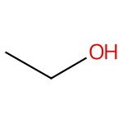 |  | 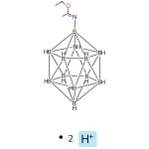

Nucleophilic addition reactions to nitrilium derivatives [B12H11NCCH3]- and [B12H11NCCH2CH3]-. Synthesis and structures of closo-dodecaborate-based iminols, amides and amidines
By: Laskova, Julia; et al
Dalton Transactions (2022), 51(8), 3051-3059.
Find It @ Emory
10.1039/d1dt04174f
View All Sources in CAS SciFinder

Steps: 1, Yield: 100%
CAS Reaction Number: 31-614-CAS-34355992
1.1 | Solvents: Acetonitrile; 12 h, rt

5. Scheme 5 (1 Reaction)

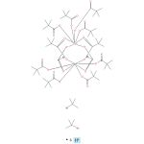  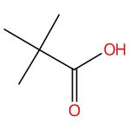 |  | 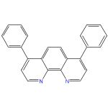
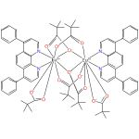

Synthesis, Structure, Thermal Stability, and Magnetic and Luminescence Properties of Dinuclear Lanthanide(III) Pivalates with Chelating N-Donor Ligands
By: Fomina, Irina G.; et al
European Journal of Inorganic Chemistry (2012), 2012(22), 3595-3610, S3595/1-S3595/6.
Find It @ Emory
10.1002/ejic.201200235
View All Sources in CAS SciFinder

Steps: 1, Yield: 93%
CAS Reaction Number: 31-614-CAS-30792721
1.1 | Reagents: Oxygen; 80 °C; 20 °C

6. Scheme 6 (1 Reaction)

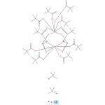

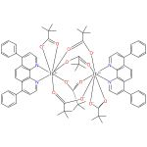

Synthesis, Structure, Thermal Stability, and Magnetic and Luminescence Properties of Dinuclear Lanthanide(III) Pivalates with Chelating N-Donor Ligands
By: Fomina, Irina G.; et al
European Journal of Inorganic Chemistry (2012), 2012(22), 3595-3610, S3595/1-S3595/6.
Find It @ Emory
10.1002/ejic.201200235
View All Sources in CAS SciFinder

Steps: 1, Yield: 92%
CAS Reaction Number: 31-614-CAS-29972262
1.1 | Reagents: Oxygen; 80 °C; 20 °C

7. Scheme 7 (1 Reaction)

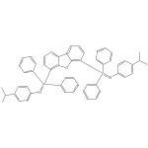 |  |  |  | 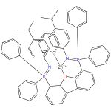
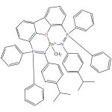

Cationic zinc complexes: a new class of catalyst for living lactide polymerization at ambient temperature
By: Wheaton, Craig A.; et al
Chemical Communications (Cambridge, United Kingdom) (2010), 46(44), 8404-8406.
Find It @ Emory
10.1039/c0cc03463k
View All Sources in CAS SciFinder

Steps: 1, Yield: 97%
CAS Reaction Number: 31-562-CAS-5520886
1.1 | Solvents: Toluene; 30 min, rt

8. Scheme 8 (1 Reaction)

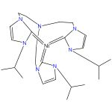 |  | 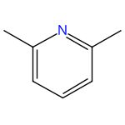 |  | 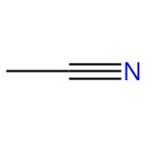
3031473-79-4
Image Not Available

Closed Synthetic Cycle for Nickel-Based Dihydrogen Formation
By: Hosseinmardi, Soosan; et al
Chemistry - A European Journal (2023), 29(64), e202302063.
Find It @ Emory
10.1002/chem.202302063
View All Sources in CAS SciFinder

Steps: 1, Yield: 97%
CAS Reaction Number: 31-614-CAS-39889228
1.1 | Solvents: Tetrahydrofuran; 1 h, 0 °C
1.2 | rt

9. Scheme 9 (1 Reaction)

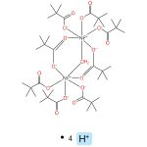 |  | 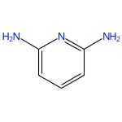
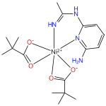

Influence of the nature of organic ligands on the character of thermal decomposition products of CoII and NiII pivalate complexes with amino derivatives of pyridine
By: Fomina, I. G.; et al
Russian Chemical Bulletin (2010), 59(6), 1175-1185.
Find It @ Emory
10.1007/s11172-010-0220-2
View All Sources in CAS SciFinder

Steps: 1, Yield: 96%
CAS Reaction Number: 31-317-CAS-13832221
1.1 | Solvents: Acetonitrile; 70 °C

10. Scheme 10 (1 Reaction)

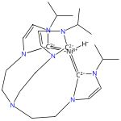
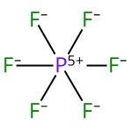

3031473-79-4
Image Not Available

Closed Synthetic Cycle for Nickel-Based Dihydrogen Formation
By: Hosseinmardi, Soosan; et al
Chemistry - A European Journal (2023), 29(64), e202302063.
Find It @ Emory
10.1002/chem.202302063
View All Sources in CAS SciFinder

Steps: 1, Yield: 96%
CAS Reaction Number: 31-614-CAS-39889232
1.1 | Solvents: Acetonitrile; 1 h, 0 °C

11. Scheme 11 (1 Reaction)

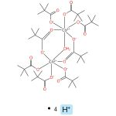 |  | 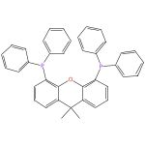
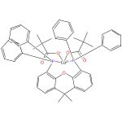

Redox Behavior of Cobalt-Phosphine Complexes vs Their Catalytic Activity in Organozinc Compound Formation: Background for Mechanistic Investigations
By: Ivanytsya, Mykyta O.; et al
Inorganic Chemistry (2023), 62(15), 5906-5919.
Find It @ Emory
10.1021/acs.inorgchem.2c03816
View All Sources in CAS SciFinder

Steps: 1, Yield: 94%
CAS Reaction Number: 31-614-CAS-36112160
1.1 | Solvents: Acetonitrile, Dichloromethane; overnight, rt

12. Scheme 12 (1 Reaction)

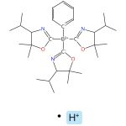 |  | 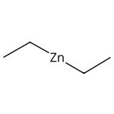 |  | 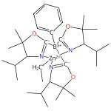

Organometallic Complexes of Bulky, Optically Active, C3-Symmetric Tris(4S-isopropyl-5,5-dimethyl-2-oxazolinyl)phenylborate (ToP*)
By: Xu, Songchen; et al
Organometallics (2015), 34(14), 3508-3519.
Find It @ Emory
10.1021/acs.organomet.5b00225
View All Sources in CAS SciFinder

Steps: 1, Yield: 94%
CAS Reaction Number: 31-562-CAS-4781114
1.1 | Solvents: Benzene; 1 h, rt

13. Scheme 13 (1 Reaction)

 |  | 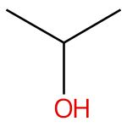 |  | 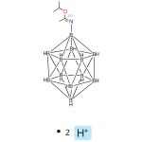  Double bond geometry shown

Nucleophilic addition reactions to nitrilium derivatives [B12H11NCCH3]- and [B12H11NCCH2CH3]-. Synthesis and structures of closo-dodecaborate-based iminols, amides and amidines
By: Laskova, Julia; et al
Dalton Transactions (2022), 51(8), 3051-3059.
Find It @ Emory
10.1039/d1dt04174f
View All Sources in CAS SciFinder

Steps: 1, Yield: 100%
CAS Reaction Number: 31-614-CAS-34355998
1.1 | Solvents: Acetonitrile; 12 h, rt

14. Scheme 14 (1 Reaction)

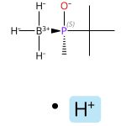  Absolute stereochemistry shown,  Rotation (+)  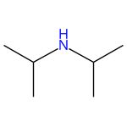 |  | 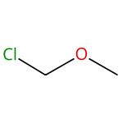 |  | 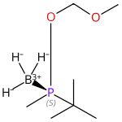  Absolute stereochemistry shown,  Rotation (+)

BOM-Phosphinite as an Electrophilic P-Stereogenic Transfer Reagent for the Synthesis of Bulky Phosphines: Synthesis of tert-Butyl(3,5-di-tert-butylphenyl)BisP*
By: Rojo, Pep; et al
Organic Letters (2021), 23(12), 4802-4806.
Find It @ Emory
10.1021/acs.orglett.1c01522
View All Sources in CAS SciFinder

Steps: 1, Yield: 94%
CAS Reaction Number: 31-614-CAS-28970322
1.1 | Reagents: Triethylamine
 | Solvents: Dichloromethane; 25 °C → 0 °C
1.2 | 0 °C; 0 °C → 25 °C; 2 h, 25 °C

15. Scheme 15 (1 Reaction)

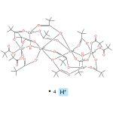 |  | 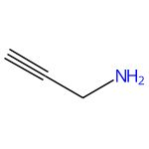 |  | 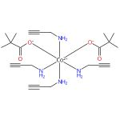

Unusual condensation of propargylamine. Generation of the 1,3-di(propargylimino)propane anion coordinated to the cobalt(III) atom
By: Sidorov, A. A.; et al
Russian Chemical Bulletin (Translation of Izvestiya Akademii Nauk, Seriya Khimicheskaya) (2001), 50(11), 2206-2211.
Find It @ Emory
View All Sources in CAS SciFinder

Steps: 1, Yield: 95%
CAS Reaction Number: 31-562-CAS-1578777
1.1 | Solvents: Dichloromethane

16. Scheme 16 (1 Reaction)

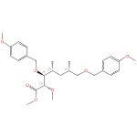  Absolute stereochemistry shown,  Rotation (-) |  | 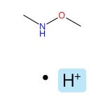 |  | 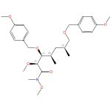  Absolute stereochemistry shown,  Rotation (-)

Total synthesis of rapamycin
By: Ley, Steven V.; et al
Chemistry - A European Journal (2009), 15(12), 2874-2914.
Find It @ Emory
10.1002/chem.200801656
View All Sources in CAS SciFinder

Steps: 1, Yield: 97%
CAS Reaction Number: 31-368-CAS-14123951
1.1 | Reagents: Bis(trifluoroacetoxy)iodobenzene, Lithium bis(trimethylsilyl)amide
 | Solvents: Tetrahydrofuran; -20 °C; 20 min, -20 °C; 1 h, -10 °C
1.2 | Reagents: Ammonium chloride
 | Solvents: Diethyl ether, Water; -20 °C → rt

17. Scheme 17 (1 Reaction)

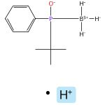 |  | 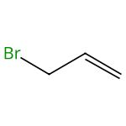 |  | 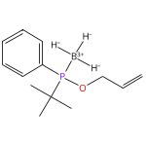

The synthesis and reactivity of phosphinous acid-boranes
By: Stankevic, Marek; et al
Synthesis (2005), (8), 1279-1290.
Find It @ Emory
10.1055/s-2005-861878
View All Sources in CAS SciFinder

Steps: 1, Yield: 94%
CAS Reaction Number: 31-614-CAS-28254306
1.1 | Reagents: Potassium carbonate
 | Solvents: Acetone; 5 min, rt
1.2 | 3 h, reflux

18. Scheme 18 (1 Reaction)

Absolute stereochemistry shown,  Rotation (+) |  |  |  | 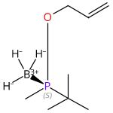  Absolute stereochemistry shown,  Rotation (+)

BOM-Phosphinite as an Electrophilic P-Stereogenic Transfer Reagent for the Synthesis of Bulky Phosphines: Synthesis of tert-Butyl(3,5-di-tert-butylphenyl)BisP*
By: Rojo, Pep; et al
Organic Letters (2021), 23(12), 4802-4806.
Find It @ Emory
10.1021/acs.orglett.1c01522
View All Sources in CAS SciFinder

Steps: 1, Yield: 91%
CAS Reaction Number: 31-614-CAS-28044381
1.1 | Reagents: Cesium carbonate
 | Solvents: Acetone; 0 °C; 0 °C → 25 °C; 15 h, 25 °C
1.2 | Reagents: Hydrochloric acid
 | Solvents: Ethyl acetate, Water; pH 1, 25 °C

19. Scheme 19 (3 Reactions)

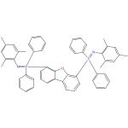 |  | 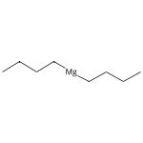 |  | 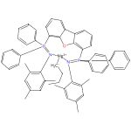

Catalysts for the polymerization of cyclic lactones
Assignee: University of Lethbridge
United States, US20100130753 A1 2010-05-27
Espacenet
View All Sources in CAS SciFinder

Steps: 1, Yield: 91%
CAS Reaction Number: 31-562-CAS-6259800
1.1 | Solvents: Benzene, Heptane; rt; 30 min, rt

Catalysts for the polymerization of cyclic lactones
Assignee: University of Lethbridge
Canada, CA2686355 A1 2010-05-24
Espacenet
View All Sources in CAS SciFinder

Steps: 1, Yield: 91%
CAS Reaction Number: 31-562-CAS-14374336
1.1 | Solvents: Benzene, Heptane; rt; 30 min, rt

Cationic Organomagnesium Complexes as Highly Active Initiators for the Ring-Opening Polymerization of ε-Caprolactone
By: Ireland, Benjamin J.; et al
Organometallics (2010), 29(5), 1079-1084.
Find It @ Emory
10.1021/om900669y
View All Sources in CAS SciFinder

Steps: 1, Yield: 91%
CAS Reaction Number: 31-562-CAS-9578733
1.1 | Solvents: Benzene, Heptane; rt; 30 min, rt

20. Scheme 20 (1 Reaction)

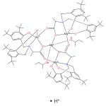  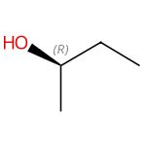  Absolute stereochemistry shown,  Rotation (-)  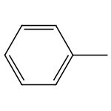 |  | 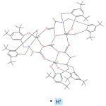 |  | Absolute stereochemistry shown,  Rotation (-)

Bulky metallocavitands with a chiral cavity constructed by aluminum and magnesium atrane-likes: enantioselective recognition and separation of racemic alcohols
By: Li, Yingguo; et al
Dalton Transactions (2015), 44(12), 5692-5702.
Find It @ Emory
10.1039/c4dt03848g
View All Sources in CAS SciFinder

Steps: 1, Yield: 95%
CAS Reaction Number: 31-614-CAS-27517557
No Data Available

21. Scheme 21 (1 Reaction)

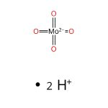  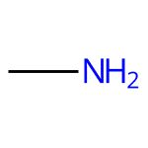 |  | 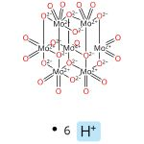

Structure Transformation of Methylammonium Polyoxomolybdates via In-Solution Acidification and Solid-State Heating from Methylammonium Monomolybdate and Application as Negative Staining Reagents for Coronavirus Observation
By: Sukmana, Ndaru Candra; et al
Inorganic Chemistry (2024), 63(22), 10207-10220.
Find It @ Emory
10.1021/acs.inorgchem.4c00543
View All Sources in CAS SciFinder

Steps: 1, Yield: 100%
CAS Reaction Number: 31-614-CAS-41524000
1.1 | Reagents: Oxygen; 1 h, 120 °C

22. Scheme 22 (1 Reaction)

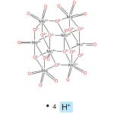

Structure Transformation of Methylammonium Polyoxomolybdates via In-Solution Acidification and Solid-State Heating from Methylammonium Monomolybdate and Application as Negative Staining Reagents for Coronavirus Observation
By: Sukmana, Ndaru Candra; et al
Inorganic Chemistry (2024), 63(22), 10207-10220.
Find It @ Emory
10.1021/acs.inorgchem.4c00543
View All Sources in CAS SciFinder

Steps: 1, Yield: 100%
CAS Reaction Number: 31-614-CAS-41524001
1.1 | Reagents: Oxygen; 1 h, 200 °C

23. Scheme 23 (1 Reaction)

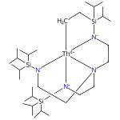 |  |  |  | 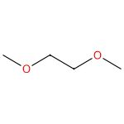
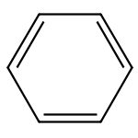 |  | 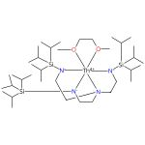

Thorium-phosphorus triamidoamine complexes containing Th-P single- and multiple-bond interactions
By: Wildman, Elizabeth P.; et al
Nature Communications (2016), 7, 12884.
Find It @ Emory
10.1038/ncomms12884
View All Sources in CAS SciFinder

Steps: 1, Yield: 91%
CAS Reaction Number: 31-562-CAS-19909206
1.1 | Solvents: 1,2-Dimethoxyethane; -78 °C → rt; 16 h, rt
1.2 | -

24. Scheme 24 (1 Reaction)

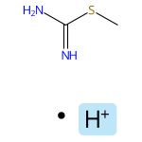 |  | 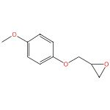 |  | 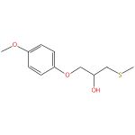

Odorless regioselective ring opening of epoxides with S-alkylisothiouronium salts as masked thiols in water
By: Panchadhayee, Rajib; et al
ARKIVOC (Gainesville, FL, United States) (2008), (2), 298-307.
Find It @ Emory
10.3998/ark.5550190.0010.228
View All Sources in CAS SciFinder

Steps: 1, Yield: 90%
CAS Reaction Number: 31-614-CAS-26354751
1.1 | Reagents: Sodium hydroxide
 | Solvents: Water; 30 min, rt

25. Scheme 25 (1 Reaction)

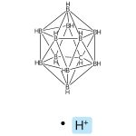  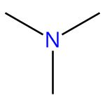 |  | 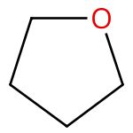 |  | 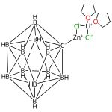  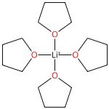

A 3D Analogue of Phenyllithium: Solution-Phase, Solid-State, and Computational Study of the Lithiacarborane [Li-CB11H11]-
By: Dontha, Rakesh; et al
Angewandte Chemie, International Edition (2019), 58(52), 19007-19013.
Find It @ Emory
10.1002/anie.201910568
View All Sources in CAS SciFinder

Steps: 1, Yield: 97%
CAS Reaction Number: 31-614-CAS-27965613
1.1 | Reagents: Butyllithium
 | Solvents: Diethyl ether, Hexane; -20 °C; 3 h, -20 °C → 20 °C; 20 °C → -20 °C
1.2 | Reagents: Zinc chloride; -20 °C; 1 h, 20 °C

26. Scheme 26 (1 Reaction)

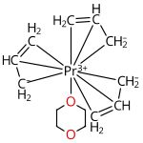

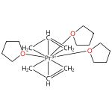

Cationic Allyl Complexes of the Rare-Earth Metals: Synthesis, Structural Characterization, and 1,3-Butadiene Polymerization Catalysis
By: Robert, Dominique; et al
Chemistry - A European Journal (2009), 15(44), 11937-11947.
Find It @ Emory
10.1002/chem.200901616
View All Sources in CAS SciFinder

Steps: 1, Yield: 97%
CAS Reaction Number: 31-562-CAS-3064847
1.1 | 30 min, rt

27. Scheme 27 (1 Reaction)

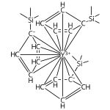

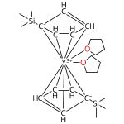

Synthesis of a Crystalline Molecular Complex of Y2+, [(18-crown-6)K][(C5H4SiMe3)3Y]
By: MacDonald, Matthew R.; et al
Journal of the American Chemical Society (2011), 133(40), 15914-15917.
Find It @ Emory
10.1021/ja207151y
View All Sources in CAS SciFinder

Steps: 1, Yield: 97%
CAS Reaction Number: 31-562-CAS-3637401
1.1 | Solvents: Toluene; 3 h, rt

28. Scheme 28 (1 Reaction)

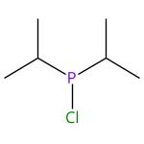

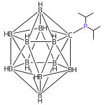
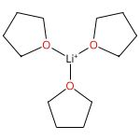

Structure and Bonding of a Zwitterionic Iridium Complex Supported by a Phosphine with the Parent Carba-closo-dodecaborate CB11H11- Ligand Substituent
By: El-Hellani, Ahmad; et al
Organometallics (2013), 32(23), 6887-6890.
Find It @ Emory
10.1021/om401001p
View All Sources in CAS SciFinder

Steps: 1, Yield: 96%
CAS Reaction Number: 31-614-CAS-25694777
1.1 | Reagents: Butyllithium
 | Solvents: Tetrahydrofuran; overnight, rt
1.2 | Solvents: Tetrahydrofuran; overnight, rt

29. Scheme 29 (1 Reaction)

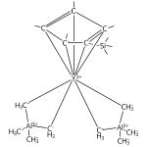

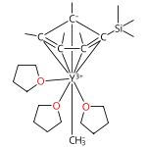

Neutral and monocationic half-sandwich methyl rare-earth metal complexes: synthesis, structure, and 1,3-butadiene polymerization catalysis
By: Robert, Dominique; et al
European Journal of Inorganic Chemistry (2008), (18), 2801-2809.
Find It @ Emory
10.1002/ejic.200800040
View All Sources in CAS SciFinder

Steps: 1, Yield: 95%
CAS Reaction Number: 31-562-CAS-13431583
1.1 | Solvents: Tetrahydrofuran; -35 °C; 30 min, -35 °C → rt

30. Scheme 30 (1 Reaction)

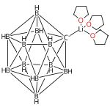

A 3D Analogue of Phenyllithium: Solution-Phase, Solid-State, and Computational Study of the Lithiacarborane [Li-CB11H11]-
By: Dontha, Rakesh; et al
Angewandte Chemie, International Edition (2019), 58(52), 19007-19013.
Find It @ Emory
10.1002/anie.201910568
View All Sources in CAS SciFinder

Steps: 1, Yield: 95%
CAS Reaction Number: 31-614-CAS-26400608
1.1 | Reagents: Butyllithium
 | Solvents: Diethyl ether, Hexane; -20 °C; 3 h, -20 °C → 20 °C
1.2 | 30 min, 20 °C

31. Scheme 31 (1 Reaction)

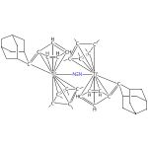 |  | 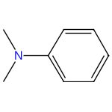
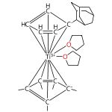

Low-Valent Pentafulvene Titanium Dinitrogen Complex as a Precursor for Cationic Titanium Complexes
By: Scherer, Axel; et al
Organometallics (2009), 28(24), 6969-6974.
Find It @ Emory
10.1021/om900875e
View All Sources in CAS SciFinder

Steps: 1, Yield: 95%
CAS Reaction Number: 31-562-CAS-371728
1.1 | Solvents: Tetrahydrofuran; rt

32. Scheme 32 (1 Reaction)

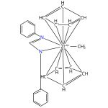 |  | 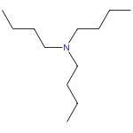
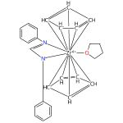

Formation and structure of a bis(cyclopentadienyl)(formamidinato)zirconium cation complex
By: Cornelissen, Carsten; et al
Zeitschrift fuer Naturforschung, B: Chemical Sciences (2004), 59(11/12), 1246-1252.
Find It @ Emory
View All Sources in CAS SciFinder

Steps: 1, Yield: 95%
CAS Reaction Number: 31-562-CAS-1317793
1.1 | Solvents: Tetrahydrofuran; overnight, rt

33. Scheme 33 (1 Reaction)

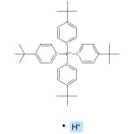 |  | 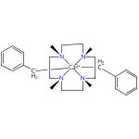  Relative stereochemistry shown
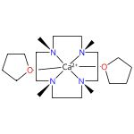
Relative stereochemistry shown
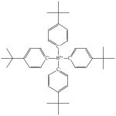

Calcium Hydride Cation [CaH]+ Stabilized by an NNNN-type Macrocyclic Ligand: A Selective Catalyst for Olefin Hydrogenation
By: Schuhknecht, Danny; et al
Angewandte Chemie, International Edition (2017), 56(40), 12367-12371.
Find It @ Emory
10.1002/anie.201706848
View All Sources in CAS SciFinder

Steps: 1, Yield: 95%
CAS Reaction Number: 31-562-CAS-17799779
1.1 | Solvents: Tetrahydrofuran; rt; 30 min, rt

34. Scheme 34 (1 Reaction)

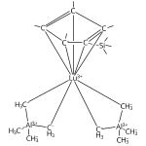

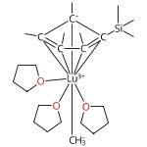

Neutral and monocationic half-sandwich methyl rare-earth metal complexes: synthesis, structure, and 1,3-butadiene polymerization catalysis
By: Robert, Dominique; et al
European Journal of Inorganic Chemistry (2008), (18), 2801-2809.
Find It @ Emory
10.1002/ejic.200800040
View All Sources in CAS SciFinder

Steps: 1, Yield: 94%
CAS Reaction Number: 31-562-CAS-8570017
1.1 | Solvents: Tetrahydrofuran; -35 °C; 30 min, -35 °C → rt

35. Scheme 35 (1 Reaction)

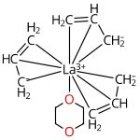

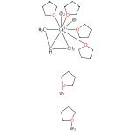

Cationic Allyl Complexes of the Rare-Earth Metals: Synthesis, Structural Characterization, and 1,3-Butadiene Polymerization Catalysis
By: Robert, Dominique; et al
Chemistry - A European Journal (2009), 15(44), 11937-11947.
Find It @ Emory
10.1002/chem.200901616
View All Sources in CAS SciFinder

Steps: 1, Yield: 94%
CAS Reaction Number: 31-562-CAS-9713760
1.1 | rt; 5 min, rt

36. Scheme 36 (1 Reaction)

Relative stereochemistry shown

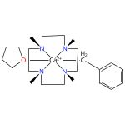
Relative stereochemistry shown
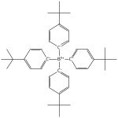

Calcium Hydride Cation [CaH]+ Stabilized by an NNNN-type Macrocyclic Ligand: A Selective Catalyst for Olefin Hydrogenation
By: Schuhknecht, Danny; et al
Angewandte Chemie, International Edition (2017), 56(40), 12367-12371.
Find It @ Emory
10.1002/anie.201706848
View All Sources in CAS SciFinder

Steps: 1, Yield: 94%
CAS Reaction Number: 31-562-CAS-17799777
1.1 | Solvents: Tetrahydrofuran; rt

37. Scheme 37 (1 Reaction)

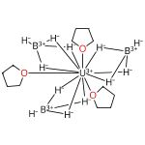

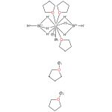

Lanthanide(III) and Actinide(III) Complexes [M(BH4)2(THF)5][BPh4] and [M(BH4)2(18-crown-6)][BPh4] (M = Nd, Ce, U): Synthesis, Crystal Structure, and Density Functional Theory Investigation of the Covalent Contribution to Metal-Borohydride Bonding
By: Arliguie, Therese; et al
Inorganic Chemistry (2009), 48(1), 221-230.
Find It @ Emory
10.1021/ic801685v
View All Sources in CAS SciFinder

Steps: 1, Yield: 92%
CAS Reaction Number: 31-562-CAS-2324233
1.1 | Solvents: Tetrahydrofuran; 2 h, 20 °C

38. Scheme 38 (1 Reaction)

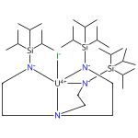

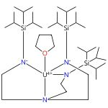

Triamidoamine-Uranium(IV)-Stabilized Terminal Parent Phosphide and Phosphinidene Complexes
By: Gardner, Benedict M.; et al
Angewandte Chemie, International Edition (2014), 53(17), 4484-4488.
Find It @ Emory
10.1002/anie.201400798
View All Sources in CAS SciFinder

Steps: 1, Yield: 92%
CAS Reaction Number: 31-562-CAS-7557950
1.1 | Reagents: (Phenylmethyl)potassium
 | Solvents: Toluene; -78 °C; -78 °C → rt; 16 h, rt
1.2 | Solvents: Tetrahydrofuran; rt → -78 °C; 1 h, -78 °C → rt; 16 h, rt

39. Scheme 39 (1 Reaction)

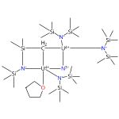

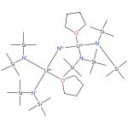

C-H Bond Activation by an Isolated Dinuclear U(III)/U(IV) Nitride
By: Palumbo, Chad T.; et al
Journal of the American Chemical Society (2020), 142(6), 3149-3157.
Find It @ Emory
10.1021/jacs.9b12804
View All Sources in CAS SciFinder

Steps: 1, Yield: 92%
CAS Reaction Number: 31-138-CAS-21446508
1.1 | Solvents: Toluene; 5 min, rt
1.2 | overnight, -40 °C

40. Scheme 40 (1 Reaction)

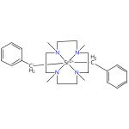 |  | 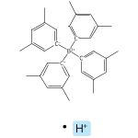
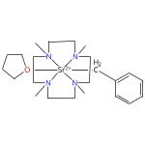
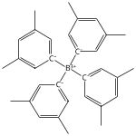

Cationic strontium hydride complexes supported by an NNNN-type macrocycle
By: Hoellerhage, Thomas; et al
Chemical Communications (Cambridge, United Kingdom) (2021), 57(51), 6316-6319.
Find It @ Emory
10.1039/d1cc02040d
View All Sources in CAS SciFinder

Steps: 1, Yield: 91%
CAS Reaction Number: 31-562-CAS-23921676
1.1 | Solvents: Tetrahydrofuran; 5 min, 23 °C
1.2 | Solvents: Pentane; 23 °C; 10 min, 23 °C

41. Scheme 41 (1 Reaction)

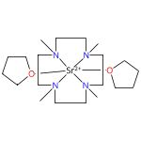

Cationic strontium hydride complexes supported by an NNNN-type macrocycle
By: Hoellerhage, Thomas; et al
Chemical Communications (Cambridge, United Kingdom) (2021), 57(51), 6316-6319.
Find It @ Emory
10.1039/d1cc02040d
View All Sources in CAS SciFinder

Steps: 1, Yield: 91%
CAS Reaction Number: 31-562-CAS-23921181
1.1 | Solvents: Tetrahydrofuran; 5 min, 23 °C
1.2 | Solvents: Pentane; 23 °C; 5 min, 23 °C

42. Scheme 42 (1 Reaction)

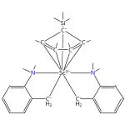

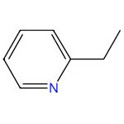 |  | 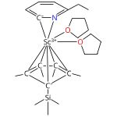

Catalytic C-H Bond Addition of Pyridines to Allenes by a Rare-Earth Catalyst
By: Song, Guoyong; et al
Chemistry - A European Journal (2015), 21(23), 8394-8398.
Find It @ Emory
10.1002/chem.201501121
View All Sources in CAS SciFinder

Steps: 1, Yield: 90%
CAS Reaction Number: 31-562-CAS-11289728
1.1 | Solvents: Tetrahydrofuran; 1 h, rt
1.2 | 4 h, 70 °C

43. Scheme 43 (1 Reaction)

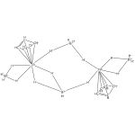

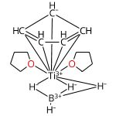

Monocyclopentadienyltitanium(III) Complexes with Hydridoborato Ligands
By: Calvo-Molina, Adrian; et al
Organometallics (2023), 42(12), 1360-1372.
Find It @ Emory
10.1021/acs.organomet.2c00580
View All Sources in CAS SciFinder

Steps: 1, Yield: 90%
CAS Reaction Number: 31-614-CAS-36982089
1.1 | Solvents: Tetrahydrofuran; 20 h, 20 °C

44. Scheme 44 (1 Reaction)

Relative stereochemistry shown

Relative stereochemistry shown
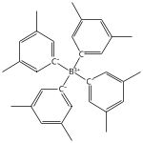

Cationic strontium hydride complexes supported by an NNNN-type macrocycle
By: Hoellerhage, Thomas; et al
Chemical Communications (Cambridge, United Kingdom) (2021), 57(51), 6316-6319.
Find It @ Emory
10.1039/d1cc02040d
View All Sources in CAS SciFinder

Steps: 1, Yield: 90%
CAS Reaction Number: 31-614-CAS-23916457
1.1 | Solvents: Tetrahydrofuran; 16 h, rt

45. Scheme 45 (1 Reaction)

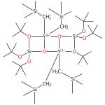

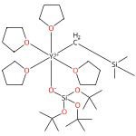

Synthesis, structure and hydrosilylation activity of neutral and cationic rare-earth metal silanolate complexes
By: Elvidge, Benjamin R.; et al
Dalton Transactions (2006), (7), 890-901.
Find It @ Emory
10.1039/b512285f
View All Sources in CAS SciFinder

Steps: 1, Yield: 90%
CAS Reaction Number: 31-562-CAS-8924467
1.1 | Solvents: Tetrahydrofuran; 1 h, 0 °C

46. Scheme 46 (1 Reaction)

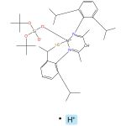 |  |  |  | 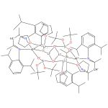

Soluble, reactive and stable - unique aluminosilicate ligands and a heterobimetallic derivative [LAl(SLi)(μ-O)Si(OLi·THF)(OtBu)2]2
By: Jancik, Vojtech; et al
Chemical Communications (Cambridge, United Kingdom) (2007), (43), 4528-4530.
Find It @ Emory
10.1039/b707895a
View All Sources in CAS SciFinder

Steps: 1, Yield: 90%
CAS Reaction Number: 31-562-CAS-11791448
1.1 | Reagents: Bis[1,1′-oxybis[ethane]]bis[μ-[1,1,1-trimethyl-N-(trimethylsilyl)silanaminato]]dilithium
 | Solvents: Tetrahydrofuran; -78 °C → rt; 2 h, rt

Copyright © 2025 American Chemical Society (ACS). All Rights Reserved.

